Windows Server & Installation

Daily Task 4

File Sharing in Windows Server

Q-1. On your Windows Server VM, create a new folder named 'MusicShare' on the D: drive and share it with the network using the Share Wizard.

- Logged in to the Windows Server VM.
- Opened File Explorer and navigated to the D: drive.
- Created a new folder named MusicShare.
- Right-clicked the folder and selected Properties.
- Opened the Sharing tab and clicked Share to launch the File Sharing Wizard.

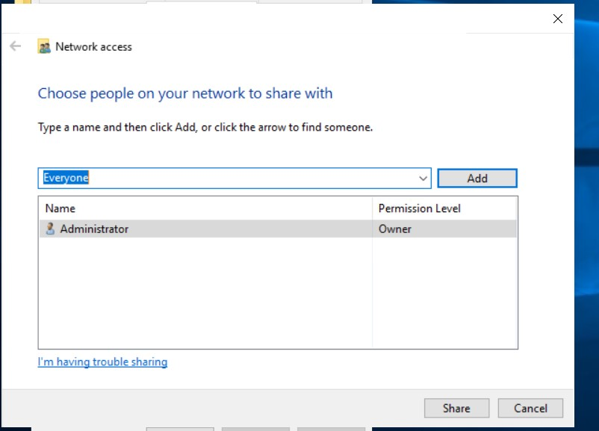
- Selected the required user or group and assigned the appropriate permission level.
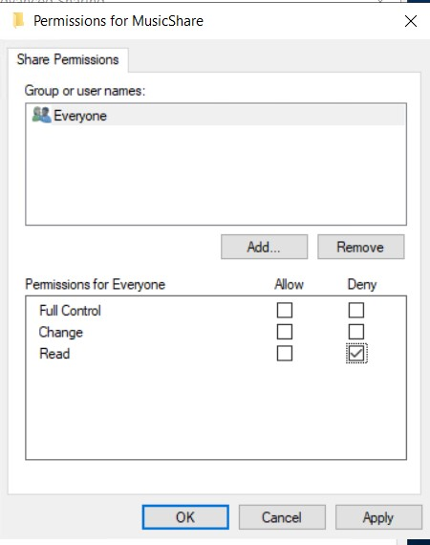
- Clicked Share and then Done to complete the sharing process.
- Verified the shared folder using the network path \\SERVERIP\MusicShare.
- Successfully created the MusicShare folder at D:\MusicShare and shared it over the network using the File Sharing Wizard.

Q-2. Set NTFS permissions on the 'MusicShare' folder so that the user 'Student1' has Read & Write access, while 'Student2' has Read-only access.
- Open File Explorer and navigate to D:\MusicShare.
- Right-click the folder and select Properties.
- Open the Security tab and click Edit.
- Click Add to add the required users.
- Select the lab.com domain as the account location and verify that Student1 and Student2 exist in Active Directory.
- Add Student1 and assign the Modify permission under Allow.
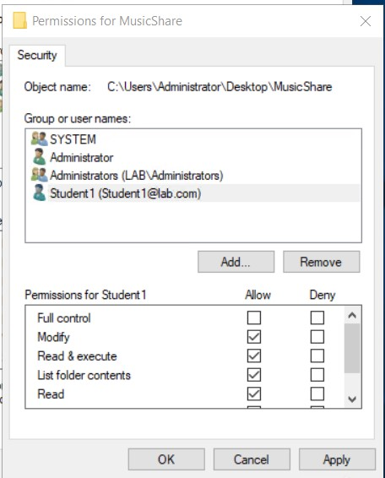
- Add Student2 and assign Read & execute, List folder contents, and Read permissions under Allow.
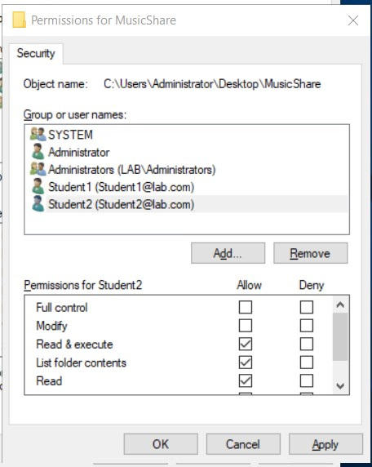
- Click Apply and OK to save the changes.
- Verify the permissions to ensure that Student1 can create and modify files, while Student2 can only read files.

Q-3. Configure Share permissions for 'MusicShare' so that only members of the 'MusicLovers' group can access the share, and all others are denied.
- Open File Explorer and navigate to D:\MusicShare.
- Right-click the folder and select Properties.
- Open the Sharing tab and click Advanced Sharing.
- Check Share this folder and set the share name to MusicShare.
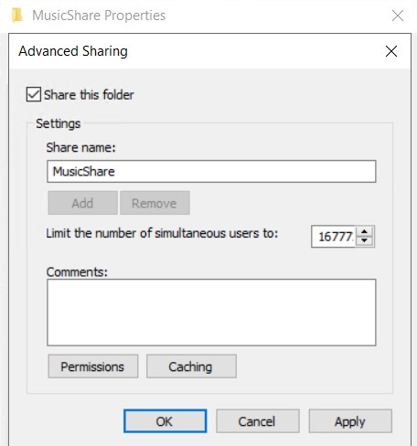
- Click Permissions to configure the share permissions.
- Remove the Everyone group from the permissions list.
- Click Add and enter MusicLovers or lab\MusicLovers, depending on the domain configuration.
- Click Check Names to verify the group and then click OK.
- Grant the MusicLovers group Read permission and, if required, Change permission. Leave Full Control unchecked unless it is specifically needed.
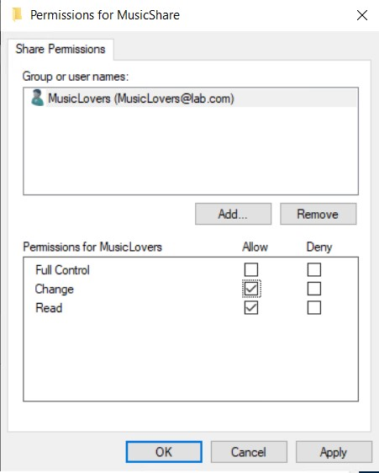
- Click Apply and OK to save the configuration.
- Share Permissions Table
Group | Read | Change | Full Control
MusicLovers | Allow | Allow, if required | Not allowed
Everyone | Removed | Removed | Removed

Q-4. Simulate these access scenarios: log in as 'Student1' and try to copy a file into 'MusicShare', then log in as 'Student2' and attempt to delete a file from the same folder. Write down what happens in each case and explain why based on the permissions set.
Student1 Copies a File
Procedure: Logged in as Student1, opened the MusicShare folder, and attempted to copy a test file into it.
Expected Observation: The file is copied successfully if Student1 has Modify NTFS permission and the share permissions allow writing.
Explanation: The Modify permission allows Student1 to read, create, edit, and delete files.
However, effective access also depends on the configured share permissions.
Student2 Attempts to Delete a File
Procedure: Logged in as Student2, opened the MusicShare folder, selected an existing test file, and attempted to delete it.
Expected Observation: Windows denies the deletion if Student2 has only Read & Execute NTFS permission and no other permission grants write or delete access.
Explanation: Read-only access allows Student2 to view and open files but does not grant permission to delete them. Both NTFS and share permissions determine the effective access available over the network.
Student1 is expected to copy files into MusicShare, while Student2 is expected to be prevented from deleting files. These results demonstrate how Windows Server permissions control file access for different users.

